Joseph Silva Jr.

11/22/2020

CS 320 Journal 4-2

SNHU

* **To what extent was your testing approach aligned to the software requirements? Support your claims with specific evidence.**

I tested each file to meet the requirement for the smaller tasks of each file given to us in the assignments. For Contact and Task files, I made sure my Junit Tests tested each string to be compliant with the smaller tasks such as each string has to be a within a certain length, and they were not allowed to be null. For ContactService.java and TaskService.java files, I made sure my Junit Tests tested each files ability to add, delete, and update either Contact List or Tasks List depending on the file.

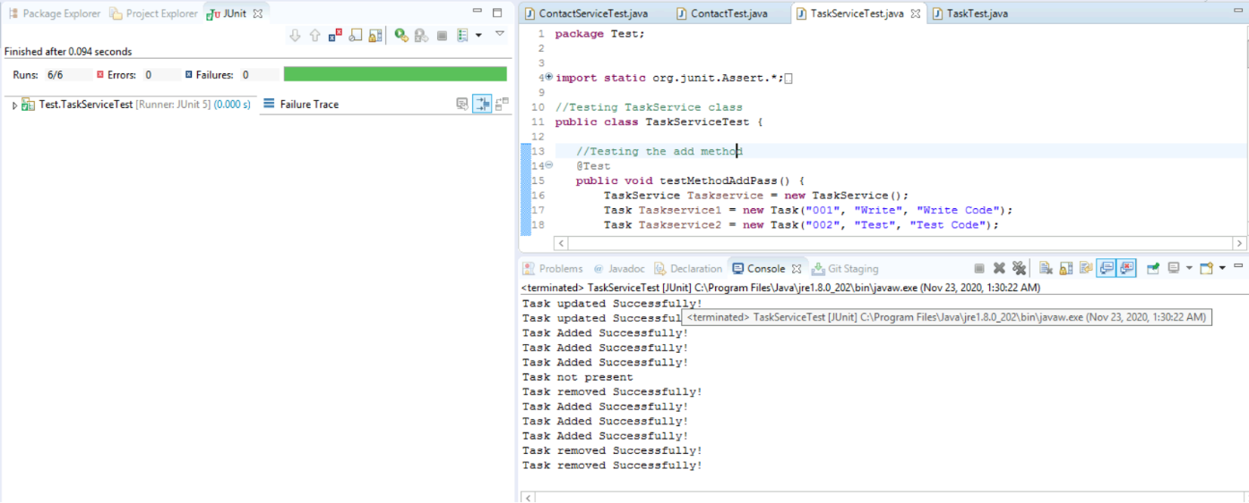

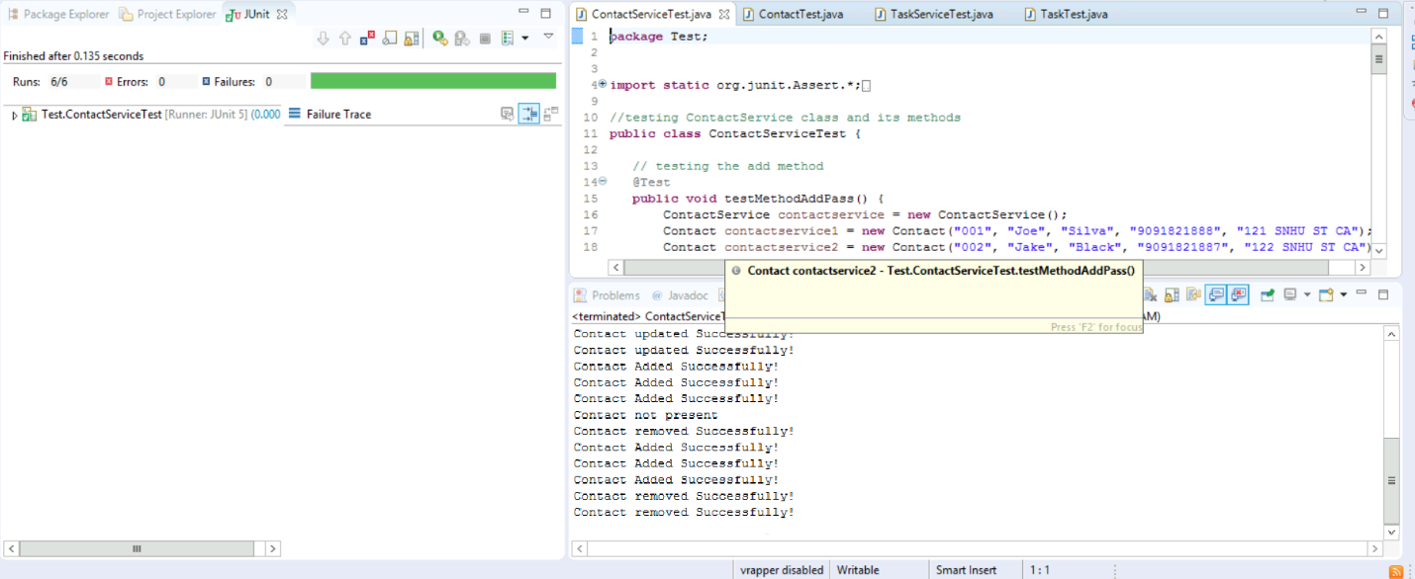

* **Defend the overall quality of your Junit tests for the contact service and task service. In other words, how do you know that your JUnit tests were effective on the basis of coverage percentage?**

The overall quality of my Junit Tests for the contact service and task service files were great. The reason I know this is because I ran multiple tests with different sets of code and there were many times where the Junit Tests with failure traces. I also ran the two codes that I uploaded to the assignment multiple times to make sure I had a 100% run rate without errors or failures. The photos above will show on the left-hand side of the photographs about the runs, errors, and failures of the Junit Tests.

* **How did you ensure that your code was technically sound? Cite specific lines of code from your tests to illustrate.**

After writing a small block of code, I would save the file in order to update any errors and/or failures within the editor area of Eclipse. I also conducted multiple tests after creating small blocks of code within the test files to test newly added blocks of code. For example, I made sure my Contact.java file met all requirements necessary for each String and then I would conduct tests using the Junit Test ContactTest.java file.

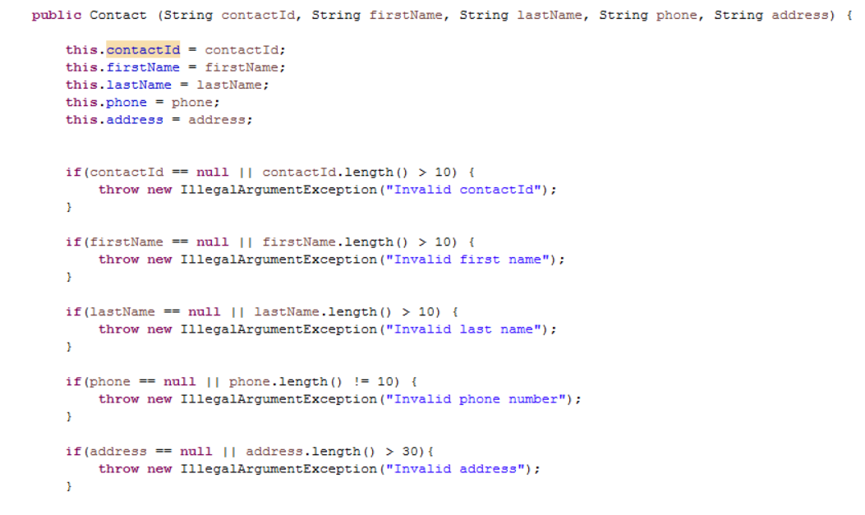

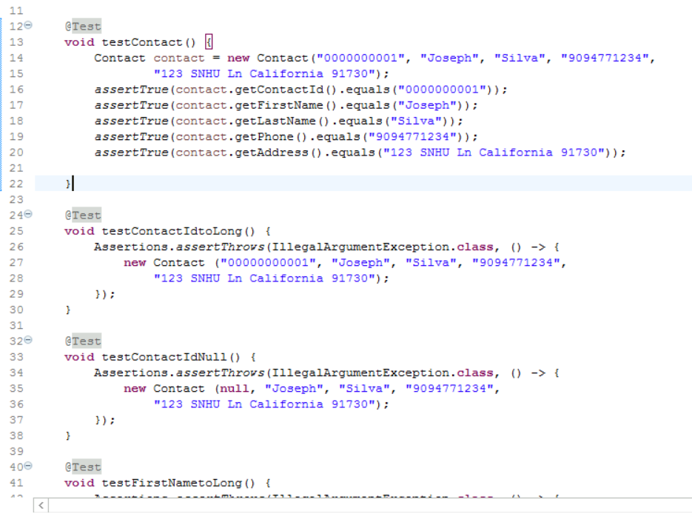

* **How did you ensure that your code was efficient? Cite specific lines of code from your tests to illustrate.**

I tested my code multiple times to make sure the runs had no errors or failures. I then checked the output console to make sure each Junit Tests gave me the output I expected. Specifically, for ContactServiceTest.java and TaskServiceTest.java, I checked for the files ability to add, remove, and update information as I previously stated above. In photos show below, I wrote small blocks of code to test ContactService.java file ability to delete contact information using a contactId. I then wrote small blocks of code to test my code in ContactService.java file using ContactServiceTest.java Junit Test to make sure the I obtained the expected output without any errors or failures.

